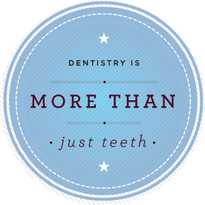 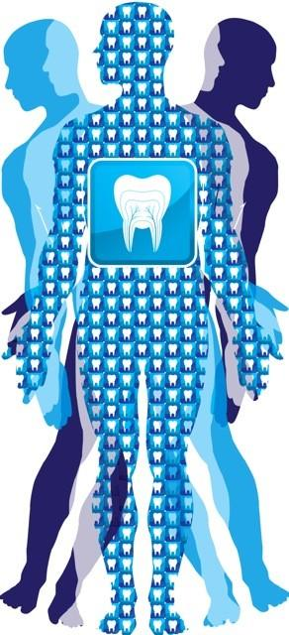

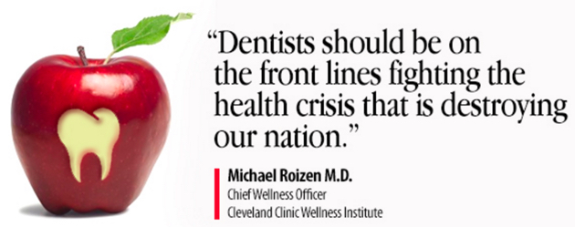

Kathryn Gilliam, BA, RDH

**Powerful strategies to transform your practice, your team, and your patients**

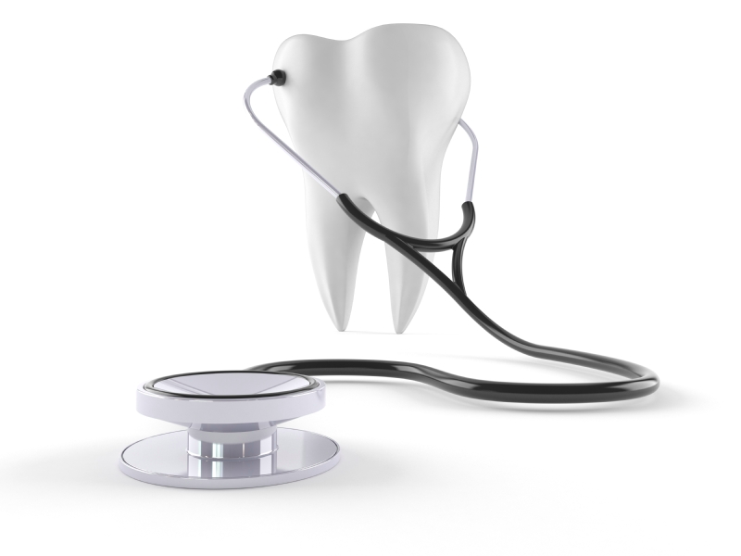

**Kathryn Gilliam, BA, RDH**

*Oral Health Educator, Trainer, Consultant, Coach, Author, Speaker*

Kathryn’s interest in the medical side of dentistry led her to years of advanced study into the oral-systemic link, including joining the American Academy of Oral Systemic Health and graduating from the prestigious Bale-Doneen Preceptorship. Her company, PerioLinks, LLC, was born out of her drive to train dental teams to transform their practices to care for the total health of their patients through comprehensive periodontal treatment. Kathryn is a passionate leader in the fight against oral cancer, inspiring dental teams to elevate their standard of care and their standard of caring.

We’re not just cleaning teeth -

we’re saving lives.

Kathryn focuses on delivering evidence-based information, supporting teams in seamless implementation and ensuring results that far exceed client’s expectations.

* Receive comprehensive training on oral-systemic link and whole body health through dental care
* Elevate communication skills and confidence when presenting whole body health
* Maximize practice growth by boosting treatment acceptance
* Increase patient referrals and attract new patients interested in whole health care
* Create consistent effort and alignment with an engaged, enthusiastic team
* Develop sustainable systems and protocols, reducing stress

832.264.8343

Kathryn@periolinks.com

**Benefits of PerioLinks Coaching and Training**

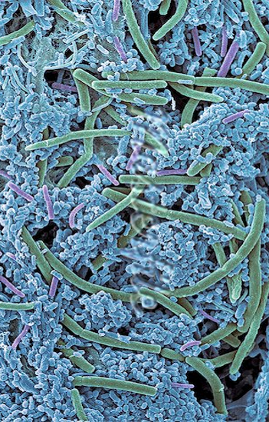

The origin of many systemic diseases can be found in periodontal disease. The pathogenic bacteria responsible for the destructive inflammatory changes we observe intra-orally are the same bacteria that contribute to many illnesses such as cardiovascular disease, diabetes, rheumatoid arthritis, and some cancers. It is critical that dental health professionals recognize the connection between periodontal disease and total health and begin to treat the whole patient. Comprehensive periodontal therapy can benefit total wellness.

# Oral-Systemic Connection

**Topics include:**

**Oral-Systemic Connection**

* The science behind the connection
* Systemic diseases associated with periodontal disease
* Diagnostic testing

**Adjunctive Therapies**

* Expanded tool kit
* Home hygiene care options

**Nutrition in Periodontal Disease**

* Gut health
* Effects of deficiency

**Early Detection of Oral Cancer**

* Risk factors
* Extra-oral and intra-oral examination techniques
* Use of fluorescence devices
* Cytology, biopsy, and referral protocols

**Medical Considerations**

* Premedication guidelines
* Vital sign standards
* Managing medically compromised patients

*Presented in half-day, full day, or two-day workshops.*

*Program available for team meetings, study clubs, conferences, and seminars.*